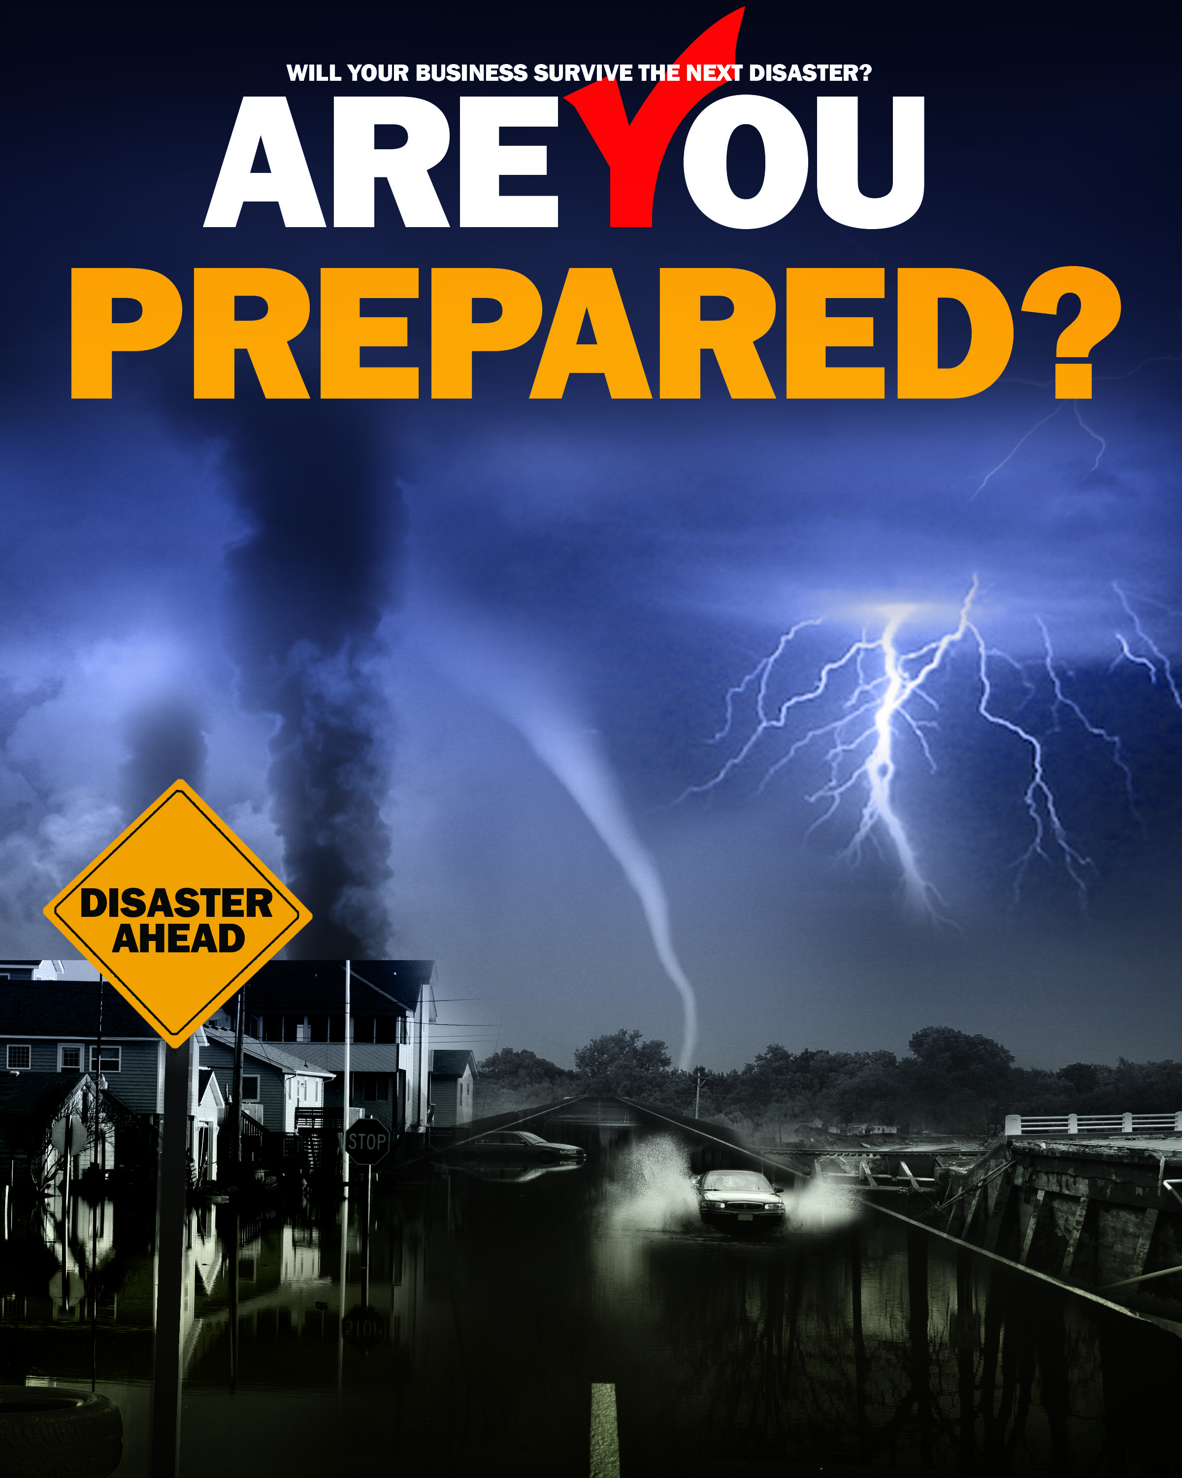
Business Continuity Plan For
< Insert Company Name Here>

Date

This report was prepared by the Boonslick Regional Planning Commission under award number 05-69-04675-01 from the Economic Development Administration, U.S. Department of Commerce. The statements, findings, conclusions, and recommendations are those of the author(s) and do not necessarily reflect the views of the Economic Development Administration or the U.S. Department of Commerce.

About Boonslick Regional Planning Commission

Mission Statement
To improve the quality of life in the Boonslick Region (Lincoln, Montgomery & Warren counties) through community, economic and workforce development initiatives; conserving and protecting natural resources; protecting the citizens through emergency planning and preparedness activities; promoting efficiency in governmental programs through sound planning practices; and promoting collaborative approaches to regional challenges.

Services Provided
Boonslick provides an array of professional services such as grant preparation and administration, solid waste administration, community planning, transportation planning, environmental planning, GIS and mapping, data management, disaster relief, and current issue forums. Activities include:
- Transportation and Traffic Analysis
- Community Planning
- Environmental Planning
- Economic Development
- Grant Writing and Administration
- Project Development, Management and Administration
- Geographic Information Systems
- Information Systems
- Data Library
The Commission also provides employment services, job training and education in cooperation with the State of Missouri. The Missouri Career Center programs include:
- Adult and Dislocated Worker Training Programs
- Youth Training Programs
- Labor Market Information
The Boonslick Regional Planning Commission takes an active role in community and economic development issues. For further information on any of these services, or to send comments regarding this website, call Steve W. Etcher, Executive Director, at (636) 456-3473 or send an email to etcher@boonslick.org.

Business Continuity Plan
Self-Assessment Template

Instructions
This Self Assessment Template is designed to lead owners of small businesses through the process of creating a business continuity plan. Answers to the questions posed will be used to populate a unique business continuity plan tailored to your special business requirements. Depending on the size and type of business not all questions will be pertinent. In those cases, just type “NA” in the field. For example, if you are the sole owner and employee, many of the questions will become moot and can be answered with just “NA”.

While we have tried to cover every circumstance there may be considerations that we have overlooked. For those instances, a section called “Other” is included at the end of the assessment which will allow you to enter specific information that we did not ask.

The field labeled “Situation” describes the type of information intended to be entered. No input is required for Situation. The field labeled “Plan” is provided for you to insert narrative that describes what actions you have taken relevant to your plans. Each Plan field has a maximum number of characters that are available for input. If additional space is needed, attach a separate document as an Addendum to this Plan. Again, if a particular section does not apply, simply insert “NA”.

Company Information
Company Name:
Address of Main Office:
Telephone Number:
Facsimile Number:
Email Address:
Owner:
Nature of Business:
Person Preparing the Assessment:
Telephone Number of Preparer:
Email Address of Preparer:
Date Business Plan Developed:

General Description of the Company

Situation: Use this space to provide a general description of the company including its core business, history, facilities, customers, suppliers, and related resources. Describe at a high level all work spaces and warehouse space, including any areas vulnerable to specific or unusual hazards. Discuss modes of transportation and routes used to access the site by customers, suppliers, and shippers. If supporting documents such as organizational charts, photographs and maps of the building(s) are available you should so note and state where they are stored and backed up.

Plan:

Insurance Policies

Situation: Summarize the information provided in the fields below regarding insurance policies. Be sure to include your structures, office automation, tools and manufacturing equipment, and motor vehicles. If you have insurance against loss of business revenue (Business Interruption Insurance) and floods (National Flood Insurance), describe those riders as well. In addition, speak to the level of liability coverage for each of the above policies. Explain your company’s insurance planning processes. For example, do you have a plan in place to review your insurance requirements on a regular basis? Have you delegated someone to be responsible to review, maintain, update, and safe-guard your policies? Have you budgeted additional resources to improve your insurance coverage? Where are your policies stored and who is delegated to access them in the event you cannot? Be sure to include the Policy, the Level of Coverage, the Provider, the Policy Number, the Agent, and Agent Contact Information.

Plan:
Locations
Situation: Describe the location of your business and what functions are performed there. If you have additional locations, include them as well. If no other locations exist, leave the space blank. Discuss how a disaster at a particular location would impact the rest of the business. Would you have the ability to move work between locations in the event a location is unavailable. If there are unique differences between locations, discuss them here as well.

Plan:

Access to Facilities
Situation: Consider the various routes that employees, customers, and vendors may take to get to your buildings in order to work, make deliveries and pick up material for shipping. Consider the likelihood of multi-vehicle accidents, earthquakes, down power lines, etc. that can all impact the ability to conduct work from your locations. What plans have you developed to determine alternate routes to and from work? Have you shared this information with your employees and vendors? Have you involved local transportation agencies to help with developing alternate routes? Is it possible for some employees to work from home until routes open up?

Plan:

Utilities and Services
Situation: Describe the various utilities and service providers you may need to contact in the event of a disruption in your business and discuss the affect of loosing these providers may have on your business. This affect may be caused by their inability to get to your location, or your inability to pay for their services due to the interruption of business. In the form below you should list the name, address, phone number, and account number of each provider as appropriate. What plan have you developed to contact services providers and utilities in the event of a business disruption? Have you shared this with employees and vendors? Be sure to include the following services and providers; Electrical Power Provider, Natural Gas Provider,
Propane Provider, Gasoline/Kerosene Provider, Telephone / Long Distance Provider, Trash Collector, USPS and Private Delivery Services, Security Services / Alarm Companies, Food / Beverage Services, Banking and Financial Institutions, Data Storage and Back-Up Services,
Accounting and/or Payroll Services, Lawn Care Services, Credit Card Companies, and Legal Advisors.

Plan:

Potential Disasters

Situation: Provide a short narrative that discusses the various disasters you may face that can jeopardize operations at your facilities. Include any hazardous materials that may be contained in the building such as solvents, poisons, volatile liquids, etc. Speak to other contributing factors such as the building’s construction, physical location, proximity to airports and/or other sources of potential hazards, flood plains, elevation above or below grade, proximity of local fire departments, EMTs, etc.

Plan:
Potential Disasters (check each that applies):

Active Shooter | Aircraft Crash | Biological Attack
Cyber Attack | Dam or Levee Failure | Earthquake
Fire | Flood | Hazardous Materials Release
Ice Storm | Improvised Explosive Attack | Improvised Nuclear Attack
Pandemic | Power Failure | Other Man-Made Hazards
Other Natural Hazards | Radiological Release | Sabotage
Thunderstorms | Tornados | Transportation System Failure
Train Derailment | Wildfire | Winter Storm

Critical Business Functions / Critical Employees / Critical Equipment

Situation: Enumerate all functions at all locations that are critical to the business and must be continued at all reasonable costs. Explain the consequences of missing a delivery date or failing to provide a service. List any contracts or deliverables that stipulate deadlines and what the penalties are if the deadline is missed. Speak to internal business functions as well, such as meeting payroll and accounts payable obligations, invoicing customers, making loan payments, paying taxes, etc. Also list the employee and back-up employee for each function or task along with why they are critical, their address and other relevant contact information. List all equipment that is essential to operations and note whether or not the equipment is readily available for lease or purchase in the event it is damaged and cannot be repaired immediately.
Explain your plan to get each critical function up and running following a disaster. Consider delegating a person to handle critical functions, critical people, and critical equipment with a single person to coordinate the entire effort. A plan should be detailed on how your critical equipment is to be repaired or replaced in the event of an emergency. Be sure to include not only production equipment, but office equipment as well such as computers, printers, telephones, and faxes used to support your business processes. If you rely on company vehicles, make sure you include a recovery plan for loss of some or all of your fleet. Are there vehicles available to lease or borrow? Can employees use their personal vehicles in return for mileage? It is important to consider and include what the company would do to continue in business if it were not able to generate income for an extended period. For each critical function be sure to include;

Plan:

Contract or Deliverable, What Makes This Function Critical?, Term of Performance / Deadline, Penalty or Affect, Employee Responsible for Function, Why is this Employee Critical to the Function?, Address of Employee, Employee Phone, Employee Cell, Employee Email, Back-Up Employee, Back-Up Employee Address, Back-Up Employee Phone, Back-Up Employee Cell, Back-Up Employee Email, Equipment Required for this Function?, Why is this Equipment Critical?, Is There a Work-around for this Function?, How Readily Can This Equipment Be Repaired?, How Readily Available is Replacement Equipment?:

Succession Plan / Signature Authority

Situation: Describe your succession plan, that is, in the event a critical employee is incapacitated, who will fill that position until the employee returns or a new employee is brought on board. Typically this succession plan would be for executives and middle managers only but you can extend it as far down as you wish. You can also extend your signature authority to those on your succession plan, that is, in the event a decision-maker is away for an extended period, who can make decisions and sign legal documents in their stead? Briefly state how your succession plan will work, where it is kept, and how it has be communicated to employees, especially those in succession. What steps are you taking to make sure employees are capable of succeeding those above them? Do you have a signed memo on file designating signature authorities and has that been communicated to your fiscal organization, financial organizations and legal advisors? For each position be sure to list the name of the position, the current employee in that position, the successor employee and whether that successor has signature authority of the person being replaced.

Plan:

Critical Vendors

Situation: If supply chain disruptions can disable the company, what mitigation efforts can be taken to minimize the disruptions? The same goes for outgoing shipments to customers. These disruptions can be the result of strikes, litigation, fuel shortages, or raw material shortages. Do your shippers and suppliers have mitigation plans in place? Are there other sources of raw materials that can be obtained on short notice. Is your shop or a supplier’s shop staffed with union employees? Have you considered disruptions caused by strikes both inside and outside your company such as a teamster strike or airline strike. Explain how your company will continue to do business if its supply chain is interrupted. Provide the following information below for each vendor in your plan; Vendor name, Vendor Contact, Products or Services Provided, Lead Time to Replenish, Pick-up / Delivery Cycle, Pick-Up / Delivery Method, Potential Disruptions to Service, Vendor Mitigation Plan, and Alternate Source.

Plan:

Critical Information / Data

Situation: Consider your business processes and list your resources and systems used to store and retrieve critical day-to-day information essential to the operation of the company. Describe how you receive work requests, process shipping data, bill customers, and pay employees and other creditors. What if your computers and file servers were destroyed? Describe your back-up plans for electronic and physical data. How would work come into the company without computers, internet, phones, etc. Is there a manual workaround? Another office that can be used? What about accounts receivable? Can billing still be done and if so, how? Do you depend on a website for your business? Where is that hosted and is it backed up? Are your computers networked? If so, do you maintain your own file servers? Are your computer/network files backed up each day? If so, where? Locally? Off-site? How quickly could they be retrieved? Do you have a company telephone system, voice mail boxes, etc.? Who provides that and how soon can replacements be obtained? How Are Work Requests Received? By Phone?, Walk-ins?, Website?, Email?, other? How Would You Accept Work Requests if the normal method was not available? Where are customer records kept such as work in progress files, contracts and agreements, etc.? Are they backed up electronically or paper copies kept? Where are accounting records kept such as accounts payable? Accounts Received? Tax Documents? Are they backed up electronically or paper copies kept? How would you access Work In Progress information if your network or computers were down or your paper files inaccessible? Do you have a company website? Where is it hosted? Can it be used to contact customers and suppliers in the event of a business disruption? How do you pay your employees? How would they be paid in the event of a disaster where your files and computers were destroyed? Where are your employee records kept? Are they electronic files or paper? Are they backed up? Where are other important documents kept such as insurance policies, contracts, stock certificates, financial records, tax documents, etc.? Where are these documents backed up?

Plan:

Other

Situation: What other factors do you need to consider for your business continuity planning?

Plan:

Accident Prevention / Emergency Preparedness

Emergency preparedness and accident prevention, while technically not part of a business continuity plan, contribute significantly to the well-being of the company and its employees. An accident prevented is a disaster averted. Hence, it makes sense to consider accident prevention plans and emergency preparedness along with business continuity. Therefore, we have included a section on accident prevention and preparedness.

Situation: Describe what actions have been taken to prevent accidents and injuries as well as safeguard your facilities and personnel from natural and man-made disasters. Detail what fire and intrusion alarms are installed, sprinkler systems, back-up power, emergency lights, first aid kits, flashlights, back-up communication equipment, fire extinguishers, radios, etc.

Explain what your emergency plans are for evacuations and / or shelter in place for a range of potential events such as fires, bomb threats, severe storms and tornados, earthquakes, hazardous spills, active shooter, etc. Explain how your emergency drills are practiced during the year, tell how often and describe the drills, that is, what drills are run. If local first responders participate in your planning and drills say so and describe what their involvement is. If employees are trained in CPR or other emergency events, list the employees and their training. You might consider making first aid training like CPR, defibrillation, and clearing obstructions to breathing as mandatory training and sponsor the training at your facility.

Explain where your hazardous materials are stored, what materials are stored, and if you have a Material Safety Data Sheet (MSDS) posted on the storage container. If the MSDS is shared with the local first responder agencies, say so. Detail where and how the materials are stored; in a designated stowage cabinet or in an open area. Remember that even office spaces frequently have common household cleaning materials that can be dangerous. Are there potentially incompatible cleaning products stored separately in the building, minimizing the risk of a chemical reaction should there be some type of spill. Do employees get a hazardous materials refresher training annually and is an eye wash station is present?

If there are shelter in place areas designated, where are they located and for what emergencies are they used. State whether emergency exits are properly marked and if other signs are posted to aid employees in seeking shelter in place or evacuation routes. What Actions Have Been Taken to Prevent Accidents? Are Fire Alarms Installed? Are Intrusion Alarms Installed?
Are Appropriate Sprinkler Systems Installed at each Site? Are Emergency Exit Signs Visible? Are Shelter In Place Locations Identified? Are Emergency Evacuation Routes Published and Readily Available for Emergencies? Are Hazardous Materials Stored in Appropriate Containers? Are Material Safety Data Sheets Current and Readily Available at Storage Containers? Is Emergency Lighting Installed? Is Back-Up Electrical Power Available? Are Fire Extinguishers Available? Are Emergency Showers Available? Are First Aid Kits Available? Where are they located? Are Employees Trained in CPR and other First Aid? Which Employees? Are Defibrillators Available? Where are they located? Are Emergency Airways Available? Are Flashlights Available? Is There a Published Emergency Plan? Where can it be found? Are Employees Trained to the Plan? Are Emergency Drills Conducted Regularly? Who is responsible for conducting the training? Are Local First Responders Involved in Your Planning? Do You Have an Intruder in the Building plan? Do Employees Receive Annual Training in Hazardous Materials Handling?

Plan:

Recommendations for Improvement
Actions to Continue

• List the Business Continuity, Accident Prevention / Emergency Preparedness plans you plan to continue. For plans that are not included in this document, state where these plans are published and who is responsible.

• List the Business Continuity, Accident Prevention / Emergency Preparedness plans you plan to continue with minor improvements. For plans that are not included in this document, state where these plans are published and who is responsible, and the improvements you plan to make.

Recommended Short-Term Mitigation Plans
As you analyzed your current business practices to complete the continuity plan you probably noted that some mitigation steps will take additional time and money to complete. Use this paragraph to state what steps can be taken within six months to one year to improve your business continuity, accident prevention / emergency preparedness plans.

Recommended Long -Term Mitigation Plans
Use this section to annotate your more expensive, longer term mitigation plans. These could include co-lateral planning sessions with business partners and suppliers to discuss mutual aide during disasters, sharing of buildings and equipment, purchasing redundant equipment and sites, contracting with third-party solutions for off-site back-up on critical information systems and data. Because these items will require significant amounts of staff time and business capital, these solutions may take a year or more to complete.

If there are additional mitigation plans that could be taken but are not feasible due to cost or other constraints you can list them here along with your rationale for not pursuing them. This may seem a waste of time today, but when the plan is revisited in future years, the information may be useful due to changing circumstances.

